Layout guide for AL- Mansour Journal (Paper Title)

Author Name with Scientific Degree |  | Author Name with Scientific Degree
Email Address |  | Email Address
 | Author Name with Scientific Degree
 | Email Address
Abstract: All articles must contain an abstract text, which formatted using 12 point Arial (Body CS). Leave 42pt and 24pt space after and before the abstract respectively. The abstract should give readers concise information about the content of the article and indicate the main results obtained and conclusions drawn. The abstract is not part of the text and should be complete in itself; no table numbers, figure numbers, references or displayed mathematical expressions should be included. It should be suitable for direct inclusion in abstracting services and should not normally exceed 200 words in a single paragraph. Since contemporary information-retrieval systems rely heavily on the content of titles and abstracts to identify relevant articles in literature searches, great care should be taken in constructing both.
Keyword: Keyword research is a practice search engine optimization (SEO) professionals use to find and research alternative search terms that people enter into search engines while looking for a similar subject.

- Heading 1 (Introduction)
These guidelines show the layout for writing research paper using Microsoft Word to be submitted into Al-Mansour Journal.
- Heading 1 (Formatting the title)
The title is set 14 point Arial (Body CS) Bold, centered justified. The first letter of each word of the title should be capitalized. Leave 42pt of space after the title.
- Heading 1 (Formatting the text)
The text of your paper should be formatted as follows:
- Heading 1 is set 14 point Arial (Body CS) bold with no spaces after or before.
- Heading 2 is set 12 point Arial (Body CS) bold with no spaces after or before.
- The text should be set to single line 12 point Arial (Body CS).
- First line of paragraphs, sections, subsections and subsubsections should be indented by 5 mm.
- Leave 10pt spacing after paragraphs, sections, subsections and subsubsections.
- Paragraphs, sections, subsections and subsubsections should be justified.
  - Heading 2 (Numbering)
Sections should be numbered with a dot following the number and then separated by a single space:
- Sections should be numbered 1, 2, 3, etc.
- Subsections should be numbered 2.1, 2.2, 2.3, etc.
- Subsubsections should be numbered 2.3.1, 2.3.2, etc.
- Heading 1 (Figures and Tables)
Authors should try to make economical use of the space on the page; for example: avoid excessively large white space borders around your graphics and unnecessarily large amounts of white space within the graphic. Design your illustrations to make good use of the available space.
  - Heading 2 (Figures)
Each figure should have a brief caption describing it. Wherever possible try to ensure that the size of the text in your figures is approximately the same size as the main text (12 points).
    - Heading 3 (Positioning figures)
Individual figures should normally be centered but place two figures side-by-side if they will fit comfortably like this as it saves space. Place the figure as close as possible after the point where it is first referenced in the text. Figures should never appear within or after the reference list.
    - Heading 3 (Figure captions/numbering)
Use 11 point Arial (Body CS) bold for figure labels. Use words rather than symbols or abbreviations when writing figure axis labels to avoid confusing the reader. Captions should be below the figure and separated from next section by a distance of 6 points. Figures should be numbered sequentially through the text ‘Figure 1’, ‘Figure 2’ and so forth and should be referenced in the text as ‘figure 1’, ‘figure 2’,… and not ‘fig. 1’, ‘fig. 2’.
Captions should be set to the width of the figure, centred across the width of the figure, or, for narrow figures with wide captions, slightly extended beyond the width of the figure. The caption should finish with a full stop (period).
If a figure has parts these should be labelled as (a), (b), (c) etc. on the actual figure. Parts should not have separate captions.
Figure 1. Figure with short caption (caption centred).

Figure 2. In this case simply justify the caption so that it is as the same width as the graphic.

Figure 6. Two narrow figures positioned side-by-side to save space. Justify the caption. |  | Figure 7. Two narrow figures positioned side-by-side to save space. Justify the caption.

  - Heading 2 (Tables)
Note that as a general principle, for large tables font sizes can be reduced to make the table fit on a page or fit to the width of the text. Otherwise use 11 point Arial (Body CS) with no spaces after or before.
    - Heading 3 (Positioning tables)
Tables should be centred unless they occupy the full width of the text.
    - Heading 3 (Table captions/numbering)
Tables should be numbered sequentially throughout the text and referred to in the text by number (table 1, not tab. 1 etc). Captions should be placed at the top of the table and should have a full stop (period) at the end. Except for very narrow tables with a wide caption (see examples below) the caption should be the same width as the table.
Table 1. position of table caption
Table Head | Table Column Head
 | Table column subhead | Subhead | Subhead
Item | Details | Details | Details

- Heading 1 (Equations and mathematics)
Make sure that your Equation Editor or MathType fonts, including sizes, are set up to match the text of your document.
The preferred style for displayed mathematics is to center equations; however, long equations that will not fit on one line, or need to be continued on subsequent lines, should start flush left.
Equations may be numbered sequentially throughout the text (i.e., (1), (2), (3),…) or numbered by section (i.e., (1.1), (1.2), (2.1),…) depending on the author’s personal preference. Equation numbers, within parentheses, are to position flush right, as in (1), using a right tab stop.
$$e^{x}+ e^{-j}=γ (1)$$
When referring to an equation in the text, always put the equation number in brackets e.g. ‘as in equation (1)’ or ‘as in equation (2.1)’, and always spell out the word ‘equation’ in full, e.g. ‘if equation (7) is factorized’; do not use abbreviations such as ‘eqn.’ or ‘eq.’.
- Heading 1 (References)
A complete reference should provide the reader with enough information to locate the article concerned, whether published in print or electronic form. Please use the American Psychological Association style (APA) where references are numbered sequentially throughout the text. The numbers occur within square brackets, like this [2].
A basic reference list entry for a journal article in APA must include:
  - Author or authors.
  - Year of publication of the article (in round brackets).
  - Article title.
  - Journal title (in italics).
  - Volume of journal (in italics).
  - Issue of journal (no italics).
  - Page range of article.
  - DOI.
Examples
- Alibali, M. W., Phillips, K. M., & Fischer, A. D. (2009). Learning new problem-solving strategies leads to changes in problem representation. Cognitive Development, 24, 89-101.
- Ruxton, C. (2016). Tea: Hydration and other health benefits. Primary Health Care, 26(8), 34-42. doi:10.7748/phc.2016.e1162
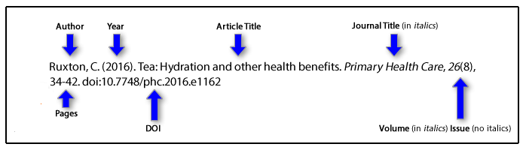
A basic reference list entry for a book (print version) in APA must include:
- Author or authors. The surname is followed by first initials.
- Year of publication of the book (in round brackets).
- Book title (in italics).
- Edition (in round brackets), if other than first edition.
- Place of publication.
- Publisher.
Example:
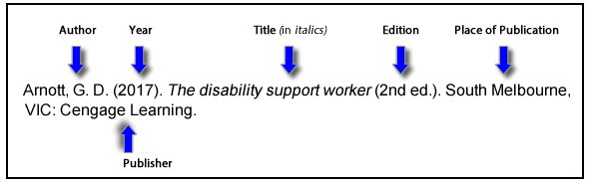
- Arnott, G. D. (2017). The disability support worker (2nd ed.). South Melbourne, VIC: Cengage Learning.
The basics of a reference list entry for a Web page or Web document:
- Author or authors. The surname is followed by first initials.
- Year (in round brackets).
- Title.
- Web address.
Example:
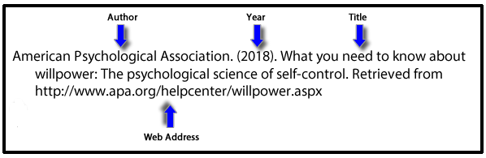
- American Psychological Association. (2018). What you need to know about willpower: The psychological science of self-control. Retrieved from www.apa.org/helpcenter/willpower.aspx

The basics of a reference list entry for an unpublished thesis:
- Author. The surname is followed by first initials.
- Year (in round brackets).
- Title.
- Level of Thesis (in round brackets).
- University.
- City.
- Country.
Example:
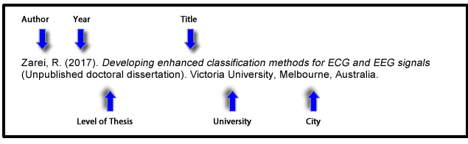
- Zarei, R. (2017). Developing enhanced classification methods for ECG and EEG signals (Unpublished doctoral dissertation). Victoria University, Melbourne, Australia.

References
- APA style

عنوان البحث باللغة العربية
اسم الباحث مع اللقب العلمي |  | اسم الباحث مع اللقب العلمي
البريد الالكتروني |  | البريد الالكتروني
 | اسم الباحث مع اللقب العلمي
 | البريد الالكتروني
المستخلص: يجب أن يوفر المستخلص للقراء معلومات موجزة عن محتوى المقال وأن يشير إلى النتائج الرئيسية التي تم الحصول عليها والاستنتاجات المستخلصة. الملخص ليس جزءًا من النص ويجب أن يكون كاملاً في حد ذاته، لا يجب تضمين أرقام الجداول أو أرقام الأشكال أو المراجع أو التعبيرات الرياضية. يجب أن تكون مناسبة للإدراج المباشر في خدمات الاستخراج ويجب ألا تتجاوز 200 كلمة في فقرة واحدة. نظرًا لأن أنظمة استرجاع المعلومات المعاصرة تعتمد اعتمادًا كبيرًا على محتوى العناوين والملخصات لتحديد المقالات ذات الصلة في عمليات البحث الالكتروني، يجب توخي الحذر الشديد في بناء كليهما.
الكلمات المفتاحية : يجب توخي الحذر في كتابة الكلمات المفتاحية.

First author’s affiliation
Second author’s affiliation
Third author’s affiliation
انتماء المؤلف الأول
انتماء المؤلف الثاني
انتماء المؤلف الثالث

